Name:
Classic China
1800 BC – 220 AD
Hour:
Shang Dynasty: 1750-1045 BC

- Xia was the first civilization but little is known about it and it was quickly replaced by the _______ dynasty.
- Shang dynasty was a ________ society, ruled by an ___________, divided into territories
- In the Shang dynasty people believed in life after death, which developed into _________ worship
- Known for using bronze in art
- Ended, possibly due to ________ leadership

Zhou Dynasty: 1045-256 BC
- Longest lasting ________ in Chinese history
- King was link between ________ and ________.
- Like the Shang dynasty, the country was divided into ___________ , each ran by an official.
- “Mandate of Heaven”
- Economic and social life began to develop: __________ , _______, trade, silk, filial piety (respect parents and relatives)
- 403 BC: civil war broke out: __________ and ___________.
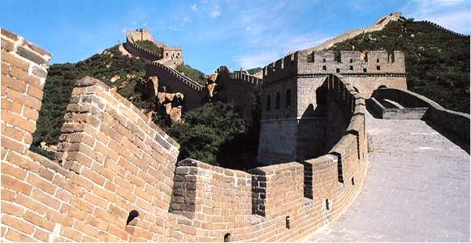
Contributions of Ancient China
- _________ language
- __________ (political and ethical)
- Daoism (duty and ___________ ; the way)
- Legalism (human beings are evil, impersonal laws)

Qin Dynasty: 221-206 BC

- The Qin dynasty defeated other warring states after a bloody ________ war
- Adopted legalism
- Highly _____________ (civil, military, censorate) (provinces, counties)
- _____________ system, roads, ______________ aggressive

The Great Wall
- Concerned with the ____________border due to _____________ tribes that rode on horseback
- Project: _________ ___ ______!!!
- Wall we know today wasn’t built until ______ years later
- Fell due to angry citizens; civil war again

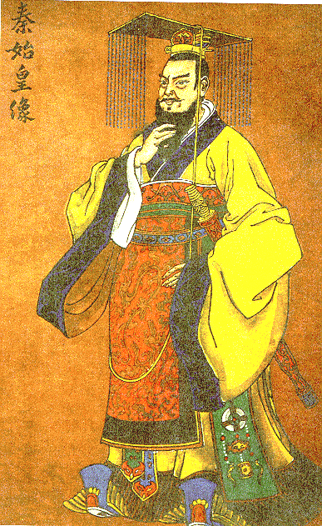
Han Dynasty:202 BC-220 AD
- ___________ harsh policies of the Qin dynasty
- Used Confucianism
- Kept ______________and local government
- Chose government officials based on ______.
- Population ________.
- Empire expanded s___________.
- Prosperous, but life was hard for peasants

Technology in the Han Dynasty
- ___________ manufacturing
- Water mills
- Iron casting
- _______
- Rudder and rigging

Fall of the Han Dynasty

- ______ rulers wasted time and money on “court life”
- Central government _____ power, nobles gained power
- __________ and social decay
- Nomadic raids
- Peasant uprisings and rebel armies led to…

……..Four hundred years of no official government……
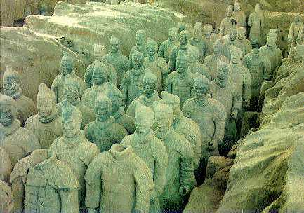

Ancient Chinese Culture

- Schools
- Confucian classics
- Terra cotta sculpture

