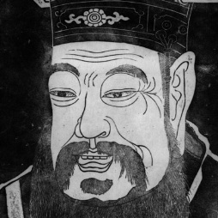
Name:
Hour
Classic China Chart
Write significant information about each civilization for each category | Economy | Social Structure | Government | Religion/Culture | War
Shang
(book pages 89-91)

Zhou
(pg. 91-97)

Qin
(pgs. 98-100)

Han
(pgs. 100-103)

